NAME: ___________________________________________ CP: 1 2 3 4 DATE: ______________________________

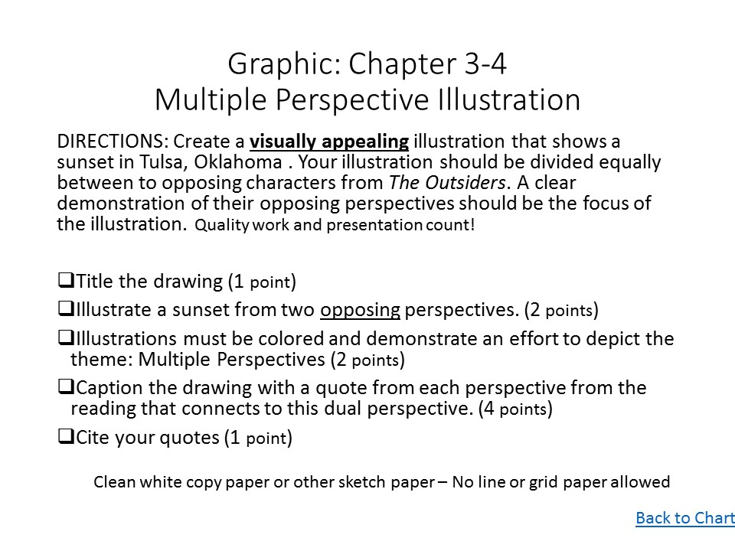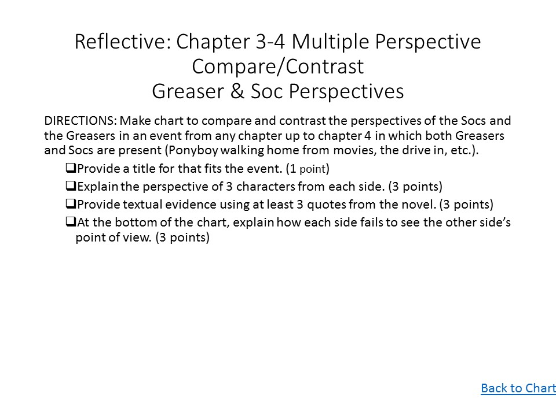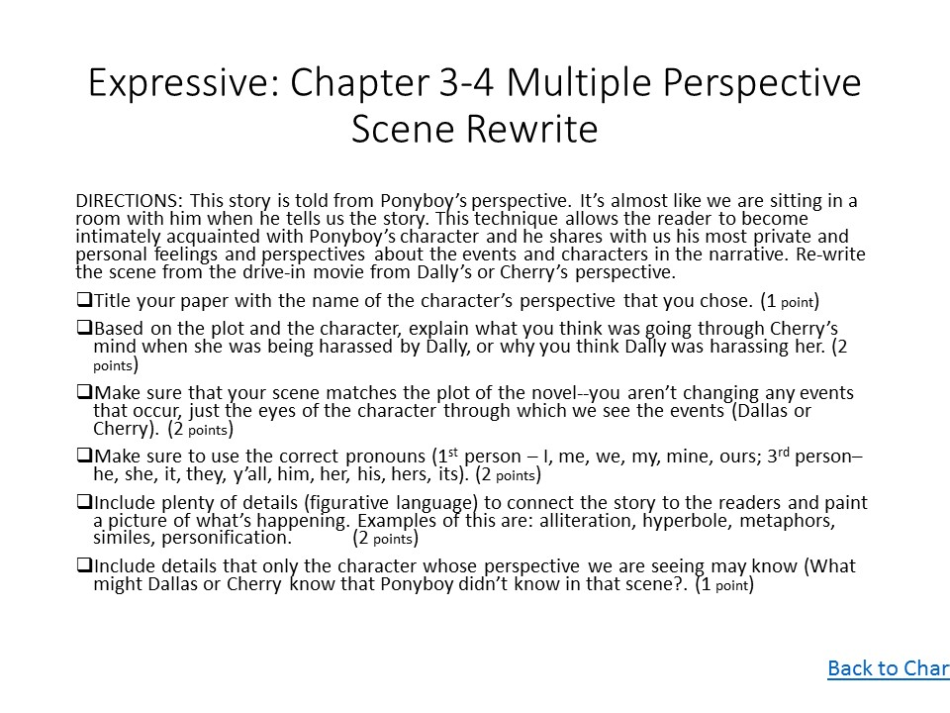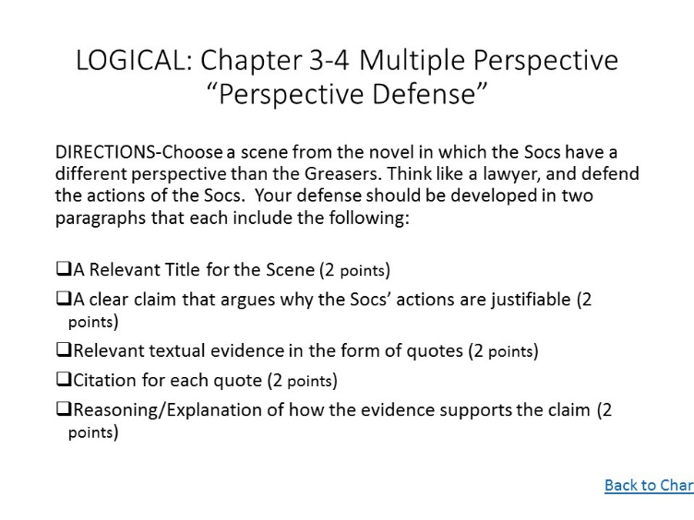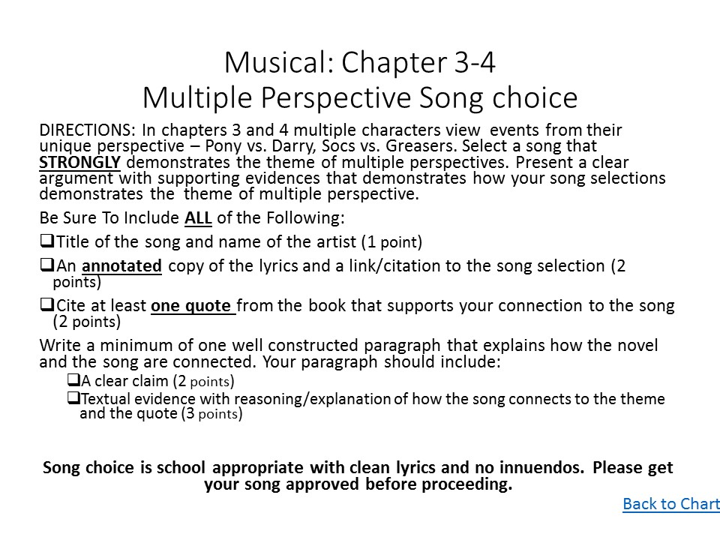

Expressive: <http://vocaroo.com/i/s1ARCAhuNP59>

 

Logical: <http://vocaroo.com/i/s12rsdWZZ0II>

Musical: <http://vocaroo.com/i/s0IriW4qBhZv>



Task 2 Overview: <http://vocaroo.com/i/s1C2cHEFxYmU>

 

Graphic: <http://vocaroo.com/i/s0uURpoQKKmI>

Reflective: <http://vocaroo.com/i/s10cLstAgPUk>

