Hatchet Final Test Recovery
6th Grade Language Arts, 6th Grade Advanced Content Language Arts
For any grade lower than an 89, you may download a recovery packet and complete the following steps to begin the recovery process, improve your grade, and demonstrate content mastery.
Part I: Passage Annotation
Complete the passage annotation and questions in the recovery packet.

Part II: Plot Diagram for Hatchet
Complete plot diagram for the book. There must be at least one entry from each chapter. Select significant events – remember you are trying to visually see the sequence of events and understand how the plot unfolded and how significant events played a part in Brian’s transformation.

Part III: Error Analysis of Hatchet Test (during ELA morning tutoring)
Upon returning to school from winter break attend a tutoring session(s) to complete an error analysis of your test.

Part IV: Retake Test to Demonstrate Content Mastery (during ELA morning tutoring)
When you are able to present the above materials to your teacher, she will place your name on the 6th grade language arts retake list. You may then attend 6th grade ELA tutoring sessions the week of February 29th – March 4th to retake the Hatchet Test.

*Please note: No student will be permitted to retake the test without first completing the above recovery work (Part I-Part III).
I have read the above requirements necessary to qualify to retake the Hatchet Final Test. I understand it is my responsibility to complete the requirements in order to be placed on the list. I also understand that the best grade I am able to earn is an 89.

Student Signature: ______________________________________________

Parent Signature: _______________________________________________

Name____________________________________ Class__________________ Date________________________

Hatchet Test Recovery
Part I: Passage Annotation/Questions

- Annotate Passage G and Passage H.
- Answer the questions with the passage. If you are unsure of what to annotate, annotate the text while you answer the questions.

Passage G

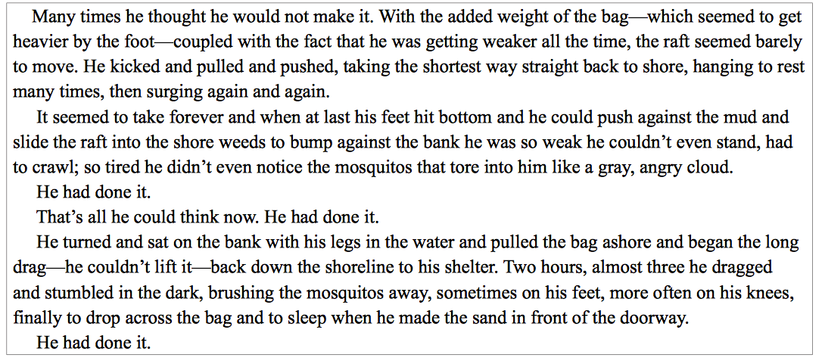

Passage G Questions
- Brian works hard to get the pack. This shows determination and perseverance. Find places in the text that help you see this.

- What is a possible theme (THE-Message) of this passage? What can you learn from Brian that you could apply to your own life?

- Underline the places where Paulsen repeats the line, “He had done it.” Why do you think he did this?

- Does Brian have hope in this passage or is he hopeless? Mark places in the text that provide evidence of the tone in this passage.

Passage H

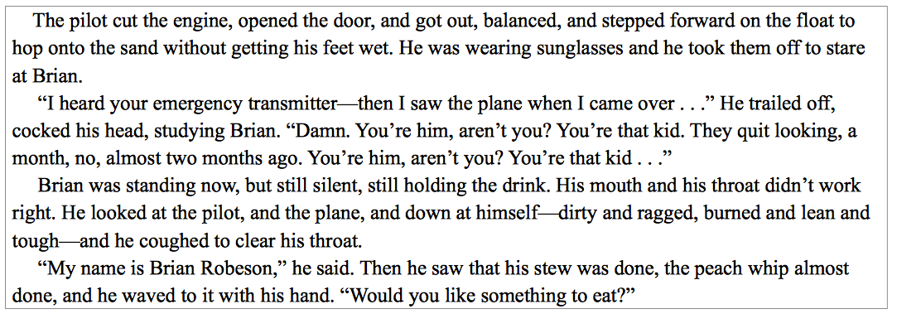

Passage H Questions
- Hatchet is written in third person point of view where the narrator is not a character in the story. This is why Paulsen uses the pronoun “he” when referring to Brian. Find places in the text that show you this point of view.

- Underline places in the text that show you Brian’s attitude towards the pilot. Describe his attitude.

- What text structure does Paulsen use when he describes the pilot and when he describes Brian? Where does he do that in this passage? What text structure does Paulsen use when he uses time order, showing you the events in this passage? Where does he do that?

Both Passages
- Look at both passages—remember these passages both occur after the climax. Where would each go on a plot diagram? Why?

- What traits (adjectives that describe a character’s behavior and attitude) does Brian have that help him to survive

Inciting Incident/Conflict Introduced:

Resolution/Denouement
Climax/Turning Point
Exposition/Introduction

Setting: ____________________________________________________________

Background: ________________________________________________________

Characters: _________________________________________________________

Point of View:________________________________________________________
ELAGSE6RL3: Describe how a particular story or drama’s plot unfolds in a series of episodes as well as how the characters respond or change as the plot moves towards a resolution.

Part II: Plot Diagram for Hatchet
by Gary Paulsen

Theme(s):
Name: _______________________________________

Class: ________ Date: _______________________

Name__________________________ Class____________________ Assessment__________________________________Date________________

Part III: GRADE RECOVERY/Error Analysis for Summative Assessment
Student must complete the following chart for each item missed in order to receive credit: item #, item answer/reason for choosing answer, correct answer/with explanation (based on text, standards and application of content/content vocabulary. If additional space is needed, please use loose-leaf paper.

Item # _______ My First Answer ________________________________________________________________________________________________
Reason:

Correct Answer_________________________________________________________________________________________________________________
Explanation:

Item # _______ My First Answer ________________________________________________________________________________________________
Reason:

Correct Answer_________________________________________________________________________________________________________________
Explanation:

Item # _______ My First Answer ________________________________________________________________________________________________
Reason:

Correct Answer_________________________________________________________________________________________________________________
Explanation:

Name__________________________ Class____________________ Assessment__________________________________Date________________

Part III: GRADE RECOVERY/Error Analysis for Summative Assessment
Student must complete the following chart for each item missed in order to receive credit: item #, item answer/reason for choosing answer, correct answer/with explanation (based on text, standards and application of content/content vocabulary. If additional space is needed, please use loose-leaf paper.

Item # _______ My First Answer ________________________________________________________________________________________________
Reason:

Correct Answer_________________________________________________________________________________________________________________
Explanation:

Item # _______ My First Answer ________________________________________________________________________________________________
Reason:

Correct Answer_________________________________________________________________________________________________________________
Explanation:

Item # _______ My First Answer ________________________________________________________________________________________________
Reason:

Correct Answer_________________________________________________________________________________________________________________
Explanation:

Name__________________________ Class____________________ Assessment__________________________________Date________________

Part III: GRADE RECOVERY/Error Analysis for Summative Assessment
Student must complete the following chart for each item missed in order to receive credit: item #, item answer/reason for choosing answer, correct answer/with explanation (based on text, standards and application of content/content vocabulary. If additional space is needed, please use loose-leaf paper.

Item # _______ My First Answer ________________________________________________________________________________________________
Reason:

Correct Answer_________________________________________________________________________________________________________________
Explanation:

Item # _______ My First Answer ________________________________________________________________________________________________
Reason:

Correct Answer_________________________________________________________________________________________________________________
Explanation:

Item # _______ My First Answer ________________________________________________________________________________________________
Reason:

Correct Answer_________________________________________________________________________________________________________________
Explanation:

